GPS tracker

GPS requires the use of many satellites orbiting the earth, gps on earth can receive signals and map the locations of four or more satellites in relation to the tracking device, it can triangulate its exact position in three-dimensional space.

<https://www.digitalmatter.com/applications/livestock-tracking/>

The tracker is kind of small, it can be easy to put on sheep, it can be placed on their backs, or on their ears, or on their necks. Snaps will be used for the connection

Combining the solar power with this device, that can use solar power to charge the tracker. Solar Photovoltaic (or PV) is a technology that converts sunlight into direct current [electricity](https://studentenergy.org/form/electricity) by using semiconductors. Solar power is kind of important since if the owner needs to charge the device, he needs to charge 150 trackers, which seems too much of work.

Or batteries can be used for this problem, but that will cost some money and batteries are not eco-friendly as solar power.

The price of GPS tracker is about 20 dollar, and the solar panel for that same size is about 5 dollars

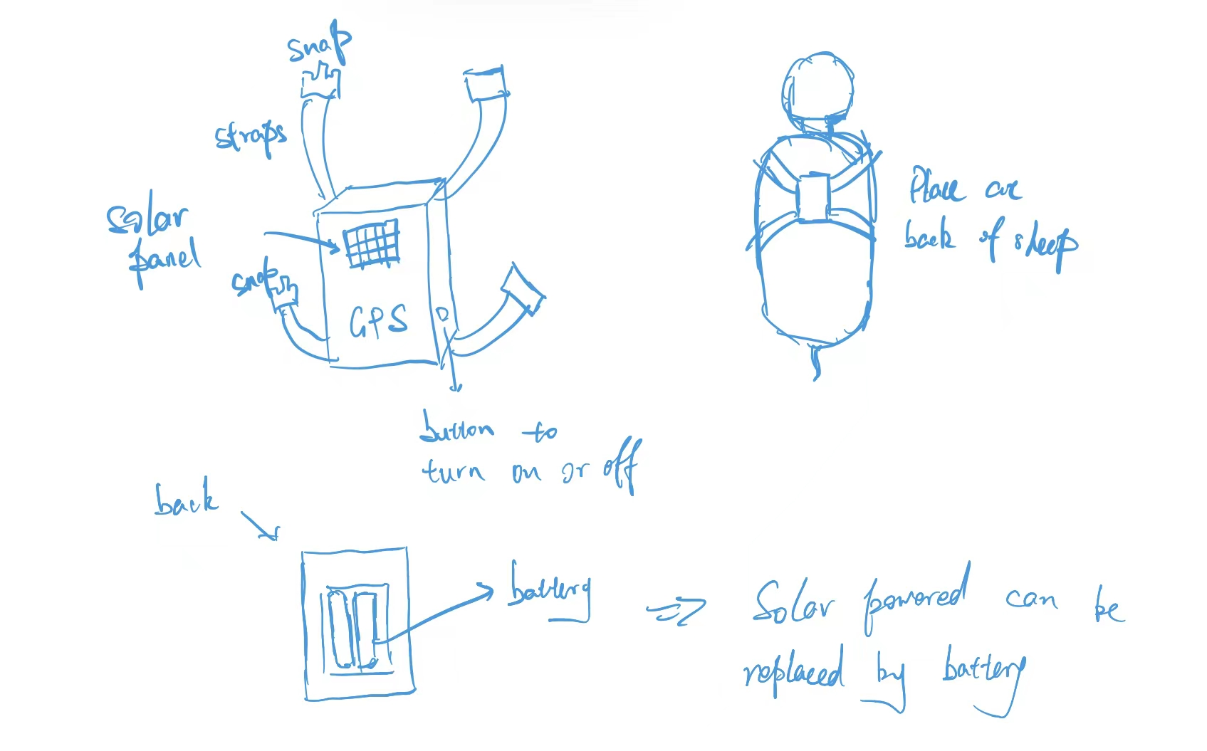

<https://www.instructables.com/Tiny-GPS-Tracker/>

<https://www.simform.com/blog/make-gps-vehicle-fleet-tracking-system-hardware/>

<https://cprimestudios.com/blog/how-build-your-own-gps-vehicle-tracking-system>

Some examples and articles about how to make the tracker